The purpose of the supply order form was to provide a method for employees of Rhema Christian Center to easily submit requests for supplies. They already had a system built within SharePoint 365, but its functions were limited and they were not configured to give all employees’ access to SharePoint. These employees are spread throughout the country, but all have access to the internet. I was able to export their current database from SharePoint to an Access Database. This allowed me to build upon the internal processes that were already established. A connector between SharePoint and the Access database was established to ensure any new additions made in SharePoint would appear in this application. This connector also sent new orders entered within this application to SharePoint to be fulfilled. Users are automatically sent email notifications with an update on each step completed within their order.

The initial page presents a login. This information is pulled from the Access database. The password is stored in an encrypted state within the database.
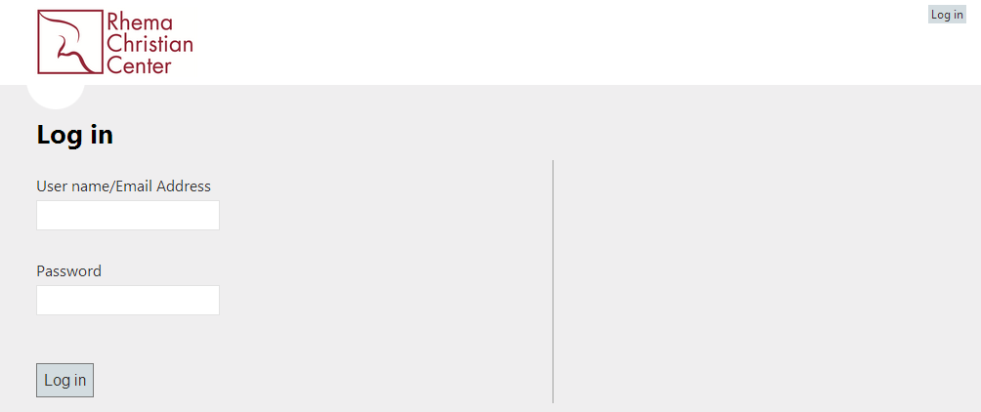

Passwords are verified.
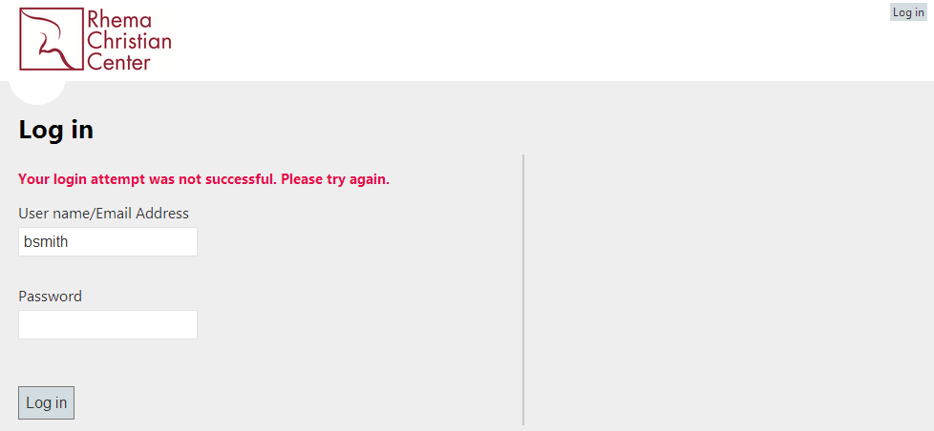
Once the user successfully logs into the application they have various options. If the users is designated as an administrator they have the ability to add new users.
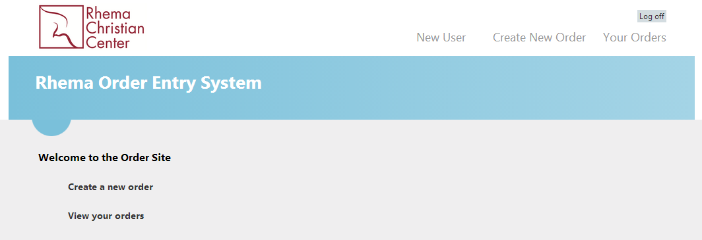

Selecting to add a new user collects basic information to build a profile.

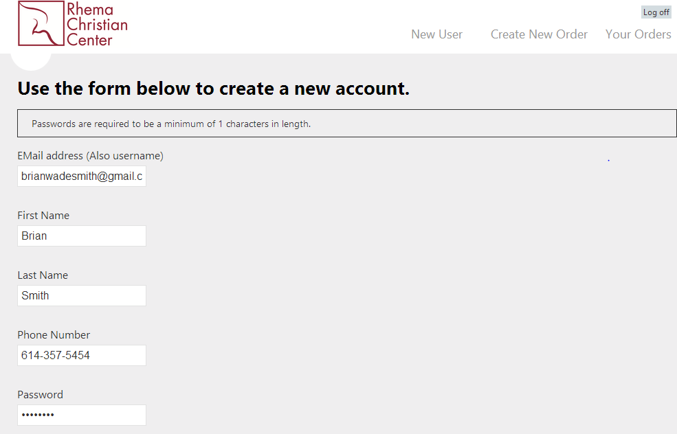
Users who are not administrators do not have asscess to create new users.
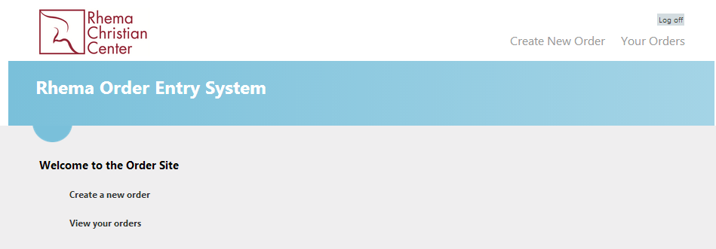

Creating an order for supplies collects the required information for the order. The Ministry dropdown is pulled from the database. They often add and remove Ministries and Departments from SharePoint. As this is done the change is replicated here.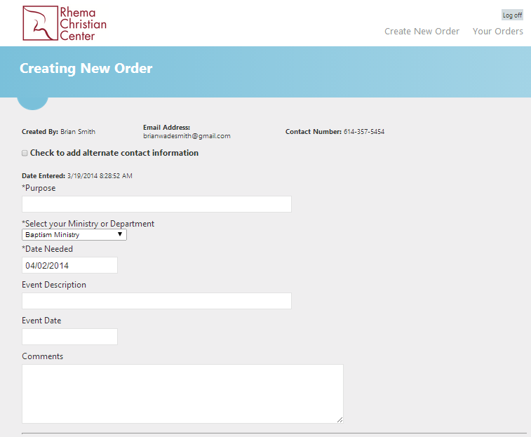
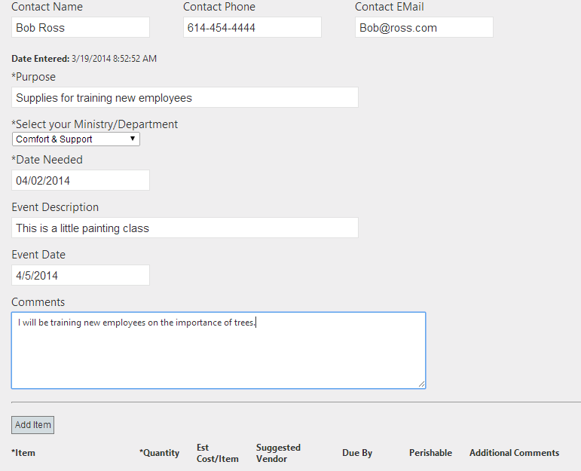
They have the option to either submit the order, save it for later, delete it, or cancel any changes.
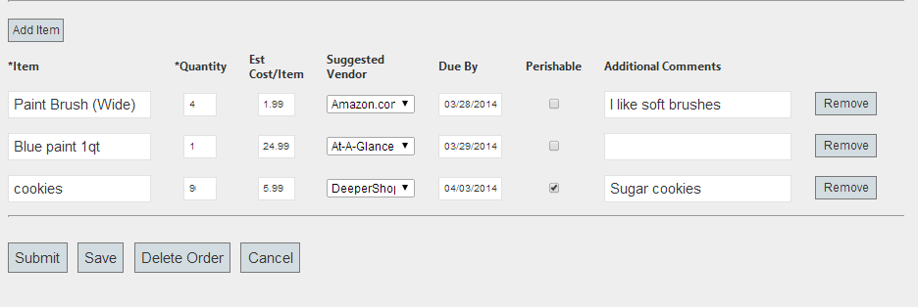

If they choose to save the entry, it can be accessed from their “Your Orders” page.
Existing orders will show all submitted, saved, and completed orders. Orders in the submitted state have been sent to SharePoint for final processing. Once the order is processed in SharePoint it will be updated in the database to show the order as completed.
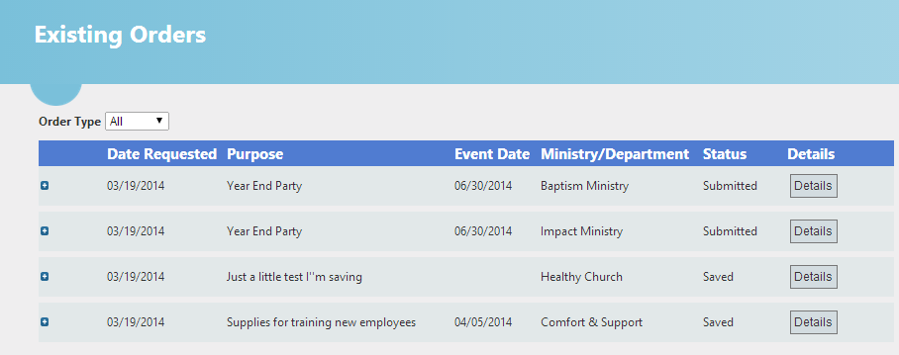
Orders can be expanded to show the items details.
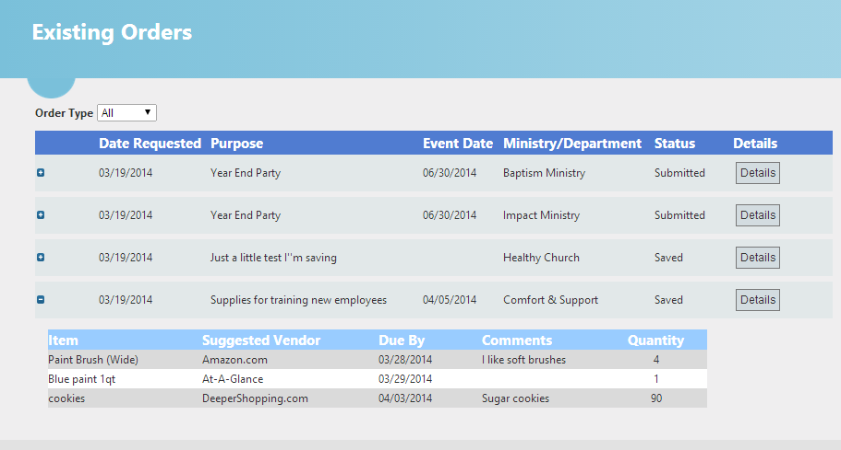
Clicking the details button on a saved order will bring the order back for editing. From this point the order can be saved again, deleted, or submitted for processing.

